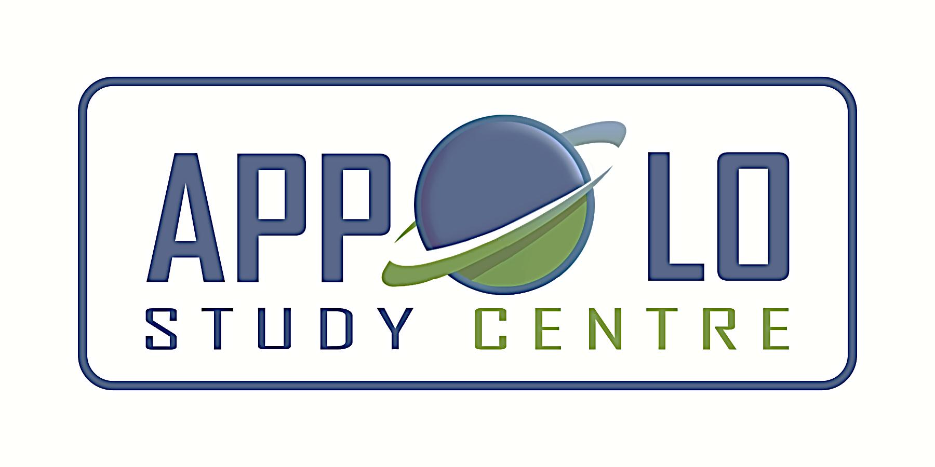
EVERYDAY CURRENT AFFAIRS–june 24, 2022
-

TAMIL NADU
- The Greater Chennai Corporation – has proposed to transform 231 corporation schools at a cost of Rs. 1,432 crore based on the proposed fundings from the European Union and France-based development agency, AFD Bank
- The revamping of schools includes the provision of cutting-edge digital infrastructure, modern furniture and better buildings
- As part of final phase-3 of transforming city schools, the corporation proposes a digital infrastructure change for smart classes, language labs, STEM labs, TABs and sports infra like football field and indoor sports facilities.
- It has also suggested funds for teaching training and skill development.

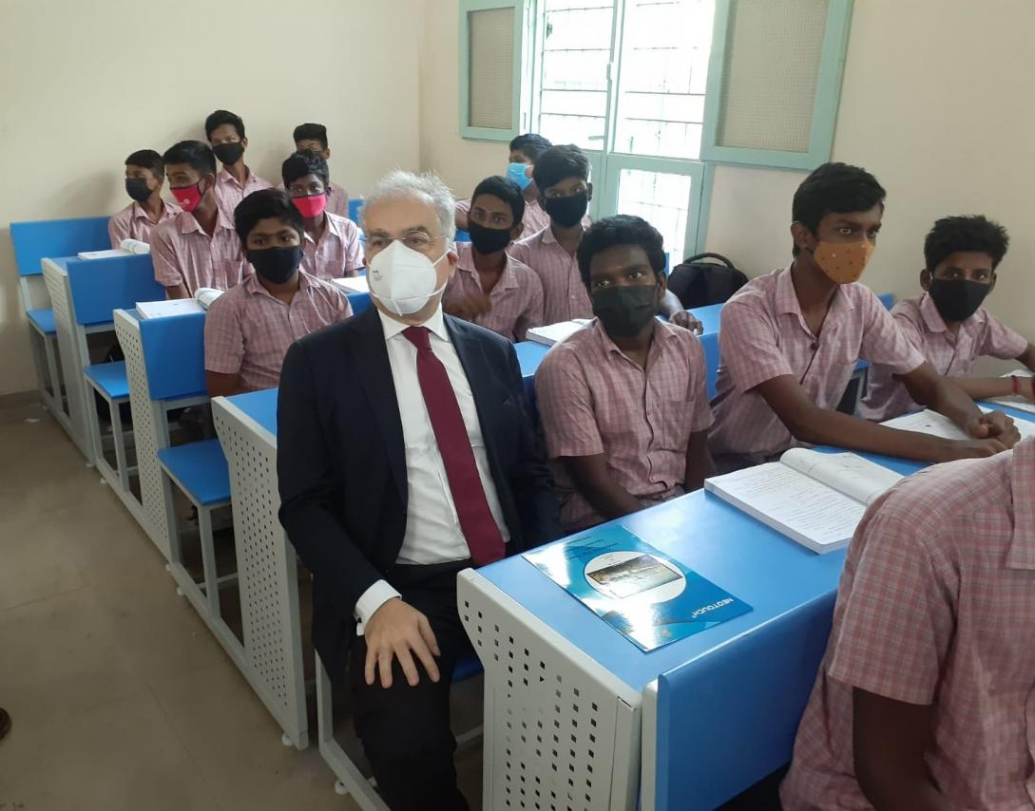

- During a two-day visit to Tamil Nadu, Ugo Astuto, ambassador of the European Union delegation to India met mayor R Priya and commissioner Gagandeep Singh Bedi.
- With the visit, Chennai is set to receive more funds from the European Union (EU) for improving climate resilience under City Investments to Innovate, Integrate and Sustain 2.0 (CITIIS 2.0) programme
- The civic body is already carrying out projects worth Rs.95.2 crore with funding from Tamil Nadu government, the Ministry of Housing and Urban Affairs (MoHUA), the Agence Française de Développement (AFD) and the European Union (EU) to develop 28 schools under the CITIIS programme implemented by Chennai smart city Limited (CSCL)
- Chennai is one of the 12 cities to have received funds and technical assistance from the CITIIS Program implemented within the Government of India’s Smart Cities Mission
- It is also the first amongst the selected cities in India to implement the programme.
- The CITIIS programme under its project “Model and Smart Corporation Schools in Chennai’, attempts to reimagine and reinvent the education experience of children attending 28 government schools run by Greater Chennai Corporation
- An analytics-based student monitoring tool will also be deployed to track and gauge the students’ performance in real time
- Consul general of France in Chennai and Puducherry Lise Talbot Barre was also present during the visit.
- The EU, which consists of 27 countries, has the world's second largest economy and its third largest population, after China and India

- On June 23, the Institute of Road Transport (IRT) on behalf of the transport department - floated a global tender for the German Bank-funded project to buy 100 new electric buses along with charging infrastructure for MTC Chennai
- As per the tender documents, all these buses will be low-floor air-conditioned with a seating capacity of 36, including one for wheelchair-bound passengers.
- The bidders are mandated to keep the floor height to less than 400mm so that passengers can easily board or alight from buses.

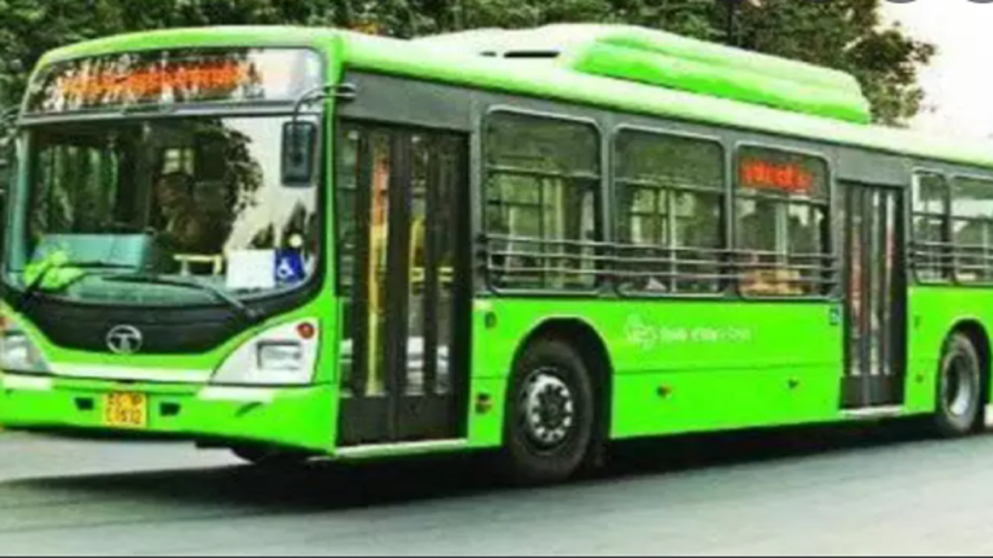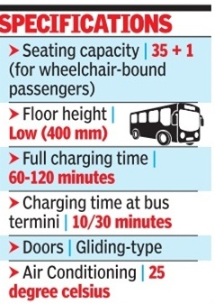

- There are also provisions to be made for having a wheelchair ramp.
- The transport department is also planning to buy another 400 buses for Chennai and other cities in Tamil Nadu, based on the success of the initial operational launch in early 2023.
- The entire procurement of all 500 buses is expected to be completed by 2024.
- On charging infrastructure, Tamil Nadu is yet to finalise the models and is open to both the categories - overnight charging and 10-30 minutes at the end of every trip.
- To replace the aged state-run buses with new buses, the State government has entered into agreement with KfW (German Development Bank) to procure 12,000 BS-VI buses and 2,000 electric buses commencing from the year 2021 in five years
- Under this project, the new buses will be procured with a cost sharing ratio of 80% (KfW) as interest-free loan and 20% share by the State government.
- Diesel buses are to be deployed in 7 State Transport Undertakings (STUs), except SETC ,and electric buses are to be deployed in Chennai, Madurai and Coimbatore cities as replacement for old buses
- Further, 2,213 diesel buses and 500 electric buses are to be purchased in the first and second phase at an estimated cost of Rs. 2,032 crore

- Ancient stone inscriptions and remains of burial urns - have been found in two villages Sithalur and Muthalur in Sivaganga district

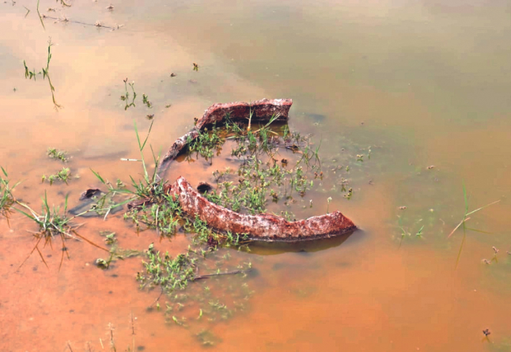

- The inscription might belong to 13th century AD, and has Tamil words like ‘Kadamai’ and ‘Andarayam’, which are associated with taxation.
- Another sentence speaks of people of the village donating a tank called Kurichikulam to the lord.
- There is a tank called Kurichikulam near Sithalur and a damaged stone pillar with inscriptions is found on its banks.
- In the neighbouring Muthalur village, burial urns were found inside a tank.
- A big burial urn — most of it under mud and only the top portion visible — and many small ones around it were found.
- There are about 15 burial urns in the vicinity of this tank.
- Some stone pillars in this village also have symbols inscribed on them, which are similar to those found in other ancient civilisations.
NATIONAL
- Archaeological Survey of India (ASI) – found large number of copper swords and harpoons beneath the soil in a field in Ganeshpur village of Uttar Pradesh’s Mainpuri district

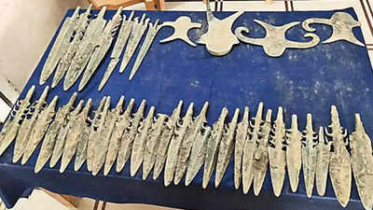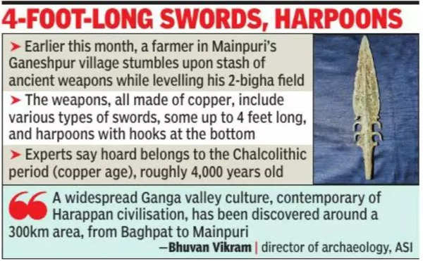

- These weapons, dating back to nearly 4,000 years, can be traced back to the copper age
- These copper swords are from the Chalcolithic period (copper age), and the appearance of Ochre Coloured Pottery (OCP) is closely related to this period
- OCP has a common period of 2,000 to 1,500 BCE, during which the pottery had a distinct red slip or Ochre colour
- The samples collected from Sanauli (Baghpat), Madarpur (Moradabad), and Sakatpur (Saharanpur) were subjected to a carbon dating experiment to ascertain the time period.
- The presence of weapons indicates that the people of this period were engaged in a conflict or war perhaps, and that could be between two large groups for land or any other rights
- Among the items discovered were various swords, some of which were called antenna swords and harpoons by archaeologists, with a hook at the bottom
INTERNATIONAL
- On June 23, the European Union leaders - agreed to grant "candidate status" to Ukraine and Moldova, while Georgia will be granted the status once the required criteria are fulfilled.
- The leaders of the EU's 27 nations unanimously decided to give its approval to grant Ukraine candidate status at a summit meeting in Brussels, Belgium
- The EU also granted candidate status to the tiny country of Moldova, another former Soviet state that borders Ukraine.
- Ukraine applied for membership on February 28, less than a week after Moscow invaded on February 24.
- Moldova followed with its own application shortly thereafter on March 3.
- To gain EU membership, countries must meet a detailed host of economic and political conditions, including a commitment to the rule of law, abolish corruption practices and other democratic principles
- The EU began in 1952 as a free-trade bloc among a core six nations.
PERSONALITIES
- Adani Group chairman Gautam Adani - has committed to donate Rs 60,000 crore ($7.7 billion) to social causes.

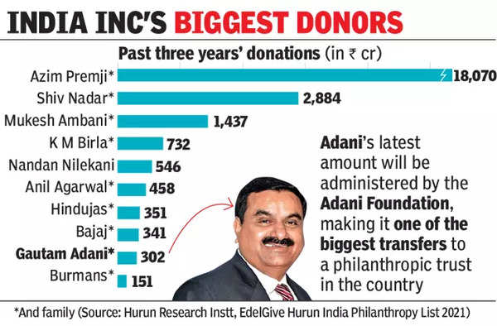

- Adani’s corpus will be administered by the Adani Foundation, making it one of the biggest transfers to a philanthropic trust in India.
- The Adani family has shown a strong philanthropic interest in healthcare, education and skill development, especially in India’s rural regions.
- Adani, who turns 60 on June 25, has an estimated net worth of $96 billion and is one of the top 15 wealthiest people in the world, according to Forbes.
- A first-generation entrepreneur, Adani’s interests span ports, power, commodities and cement.
- He owns Mundra Port, India’s biggest, in his home state of Gujarat, and is the newly anointed cement king, having announced the acquisition of Holcim India for $10.5 billion.
- In fiscal 2021, Adani donated Rs 130 crore towards disaster relief, ranking him eighth in the EdelGive Hurun India philanthropy list.
- Adani Foundation had also donated Rs 122 crore to fight the coronavirus pandemic across the country.
- With the latest move, Adani joins notable pledgers like Meta (Facebook parent) CEO Mark Zuckerberg, Berkshire Hathaway CEO Warren Buffett and Blackstone CEO Stephen Schwarzman who have committed to give a significant part of their wealth to philanthropy.

SCIENCE, TECHNOLOGY & ENVIRONMENT
- On June 23, the WHO - convened its emergency committee to consider if monkeypox may be declared a global emergency.

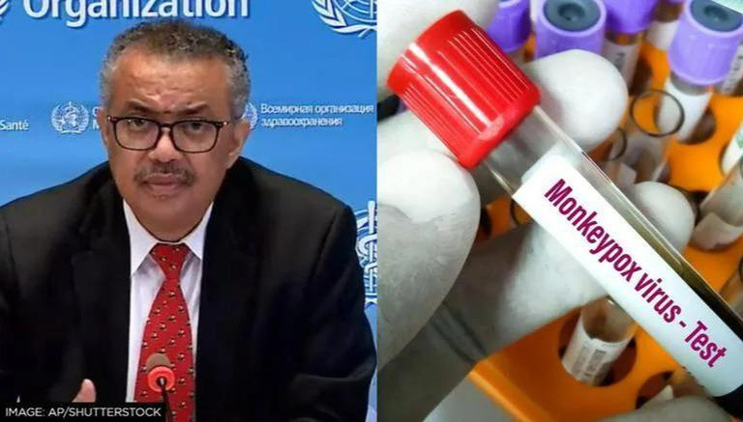

- The deliberations of the WHO’s response to the outbreak follows concerns over how the UN agency handled Covid in early 2020.
- A “public health emergency of international concern” is WHO’s highest level of alert.
- The agency does not declare pandemics, but it did start using the term to describe Covid in March 2020.
- Monkeypox does not spread nearly as easily as Covid and there are vaccines and treatments available, unlike for the coronavirus when it emerged.
- Over 3,300 cases of monkeypox have been confirmed in 42 nations where the virus hasn’t been typically seen.
- Over 80% of cases are in Europe, while there have been no reports of deaths.
- Further, on June 23, the current monkeypox outbreak was declared a pandemic by World Health Network (WHN), a global collaboration of scientific and citizen teams.
- The declaration came ahead of a WHO meeting to decide on their monkeypox outbreak designation.
- The WHN urged immediate action by the WHO and disease control and prevention organisations of various countries to prevent monkeypox becoming a disaster.
APPOINTMENTS
- On June 23, the Centre - appointed former Punjab DGP Dinkar Gupta, an IPS officer of 1987 batch, as the director general of National Investigation Agency (NIA).
- Gupta was dropped as the state police chief in October 2021 by the erstwhile Congress government led by Charanjit Singh Channi
- Gupta was posted as chairman of Punjab Police Housing Corporation (PPHC) after being replaced, as he asked permission for a central deputation
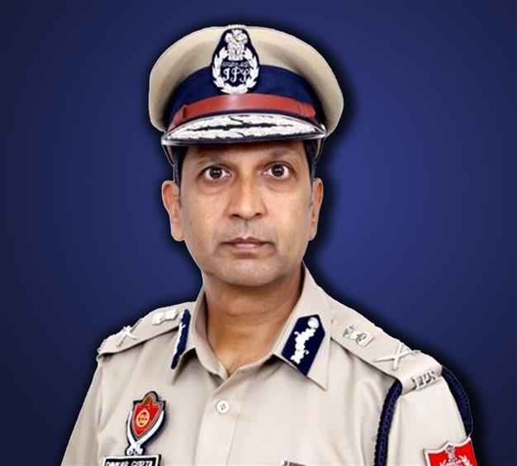

- Dinkar Gupta will be the first full-time DG of NIA ever since former NIA chief Y C Modi retired on May 31, 2021.
- CRPF DG Kuldiep Singh was holding additional charge as DG, NIA since Y C Modi’s exit.
- Dinkar Gupta will hold the NIA DG’s post till March 31, 2024, the date of his superannuation, or until further orders of the government, whichever is earlier.
- Perceived as close to then chief minister Captain Amarinder Singh, Gupta took over as Punjab police chief on February 7, 2019, by superseding many senior IPS officers.
- Dinkar Gupta was the recipient of two police gallantry medals in 1992 and 1994.
- He was also decorated with Police Medal for Meritorious Services by the President as well as President’s Police Medal for Distinguished Service in 2010.
- Further, he was awarded with British Chevening Gurukul Scholarship, in 1999 by British Council at London School of Economics, London.
SPORTS
- World football governing body, FIFA – has set September 15 as deadline to elect a new executive committee of the All India Football Federation (AIFF) and avoid an international ban
- A seven-member joint delegation from FIFA, the governing body for world football, and Asian Football Confederation (AFC) concluded its visit to India on June 23.

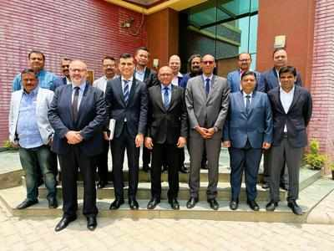
- The visiting delegation has discussed last month’s Supreme Court order that ousted Praful Patel as AIFF president and also dismissed the executive committee, whose tenure ended in December, 2020.
- The FIFA-AFC delegation has told the committee of administrators (CoA) to ensure that the redrafted AIFF Constitution is approved by the Supreme Court latest by July 31 and elections are held by September 15.
- The next steps should be the ratification of the AIFF Statutes in line with FIFA/AFC principles of good governance and the holding of an electoral congress to choose the next AIFF leadership.
- The visiting delegation led by AFC general secretary Datuk Seri Windsor John also met I-League, Indian Super League and FSDL representatives
- According to the roadmap agreed by all stakeholders three years ago, starting with the 2022-23 and 2023-2024 season, the winner of the I-League will qualify directly to the ISL with no participation fee, if they meet the national club licensing criteria announced by the AIFF.
- Gokulam Kerala FC is the two-time defending champions of I-League and they may become second team from Kerala to be in ISL if they win next year’s I-League
- There will be no relegation in the ISL till 2024-25 when promotion and relegation in the top-tier league will be implemented and the system of two parallel leagues will be abolished.
EIU RANKINGS – World’s most liveable city
