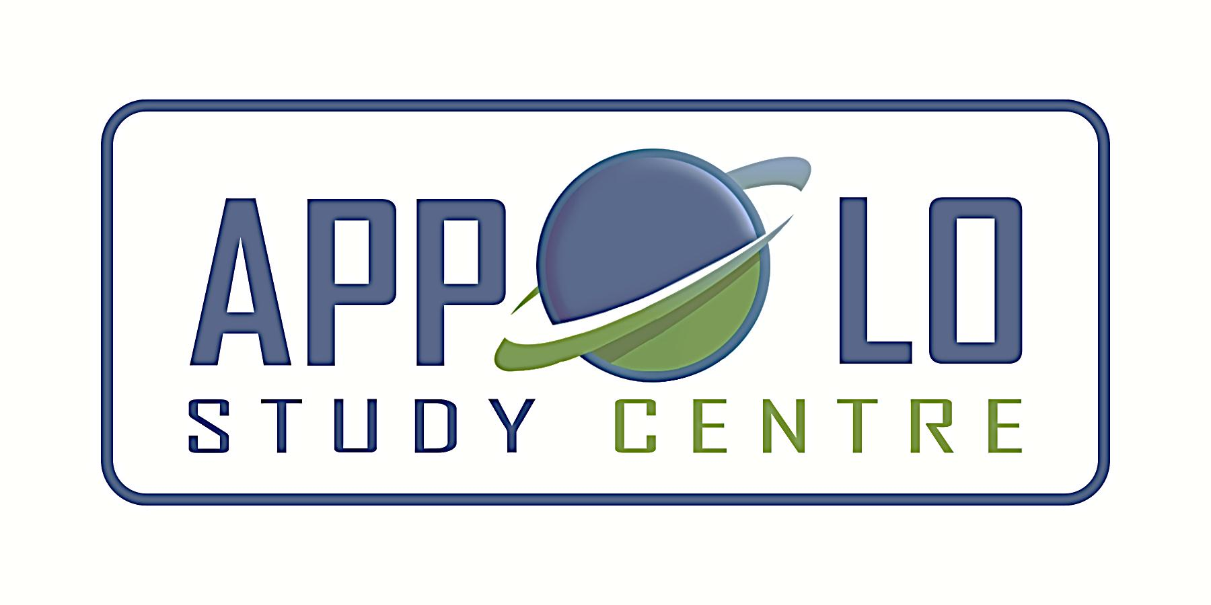
EVERYDAY CURRENT AFFAIRS – may 14, 2023
-

TAMIL NADU
- In a major reshuffle, as many as 14 IAS officers - have been shifted and given new postings in Tamil Nadu
- Chief Minister MK Stalin’s Principal Secretary T Udayachandran has been transferred and posted as Principal Secretary to Finance Department.
- He replaces N Muruganandam, who has been transferred and posted as one of the three secretaries to the Chief Minister and will also hold the post of Development Commissioner.
- The other IAS officers who were transferred include Home Secretary K Phanindra Reddy, who is being replaced by Amudha, the fourth woman to hold the post.
- Phanindra Reddy has been posted as Additional Chief Secretary to Transport Department.

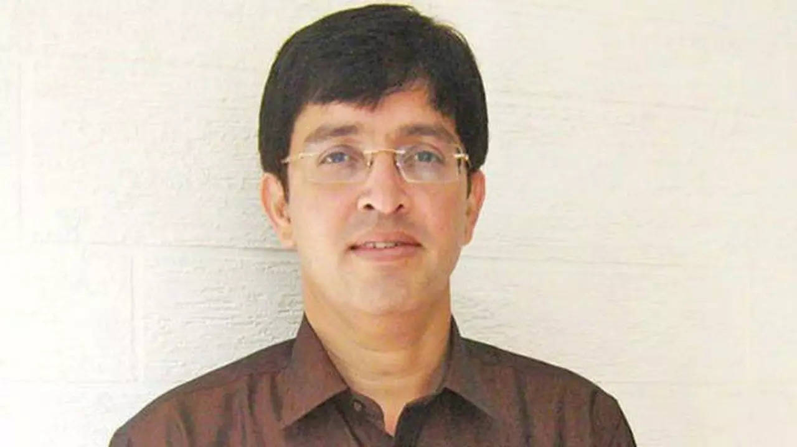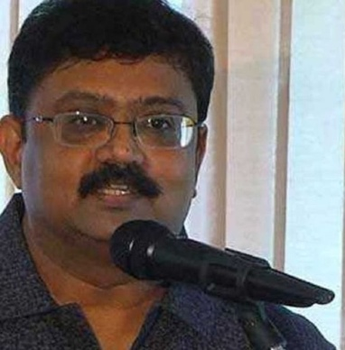

- Among the other major changes, J Radhakrishnan has been posted as Greater Chennai Corporation's Commissioner, while his predecessor Gagandeep Singh Bedi IAS has been posted as Principal Secretary to Government, Health and Family Welfare Department.
- Chief Minister M K Stalin was the mayor when J Radhakrishnan became the civic body’s youngest commissioner from January 19, 2000, to June 4, 2001.
- Dr P Senthilkumar has been transferred and posted as Principal Secretary of the Rural Development and Panchayat Raj Department, replacing Amudha.
- Dr B Chandra Mohan, who served as the Principal Secretary of the Tourism, Culture and Religious Endowments Department, is transferred and posted as Principal Secretary of the Public Works Department.
- Incumbent additional chief secretary of transport department Dr K Gopal has been posted as the new commissioner of administrative reforms, a post held as additional charge by senior IAS officer Shiv Das Meena.
- Dr K Manivasan has been transferred from the post of PWD secretary and posted to the Tourism, Culture and Hindu Religious and Charitable Endowments Department.
- Incumbent public secretary Dr D Jagannathan has been posted as the secretary of the state cooperation and food department.
- K Nanthakumar, commissioner of school education, has been posted as secretary of human resources management department, replacing Mythili K Rajendran who has been appointed as commissioner of Indian medicine and homeopathy
- S Ganesh, incumbent director of Indian medicine and homeopathy has been posted as director of economics and statistics, a post held as additional charge by Vikram Kapur.
STATES
- The Indian National Congress (INC) - has attained a majority in the Karnataka assembly election results 2023 and returned to power in the state.

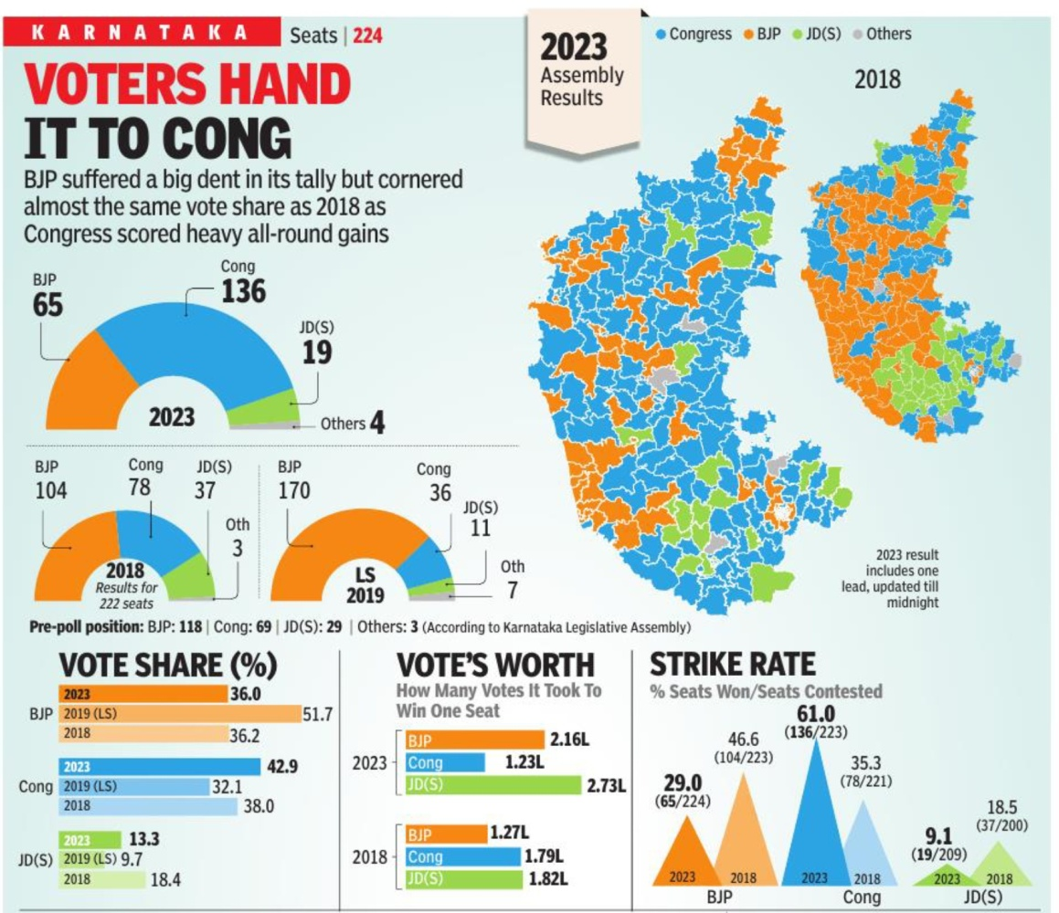
- The Congress secured a clear majority in Karnataka, winning 136 of the 224 Assembly seats in the state.
- This is the first time in a decade that a party has crossed the halfway mark in the state.
- The ruling Bharatiya Janata Party (BJP) in the state was decimated to 65 seats while Janata Dal (Secular) secured only 19 seats
- On the other hand, independent candidates won two seats, and the Kalyana Rajya Pragathi Paksha and Sarvodaya Karnataka Paksha won one seat each.
- After the results, the BJP has lost the only state it was in power in southern India.

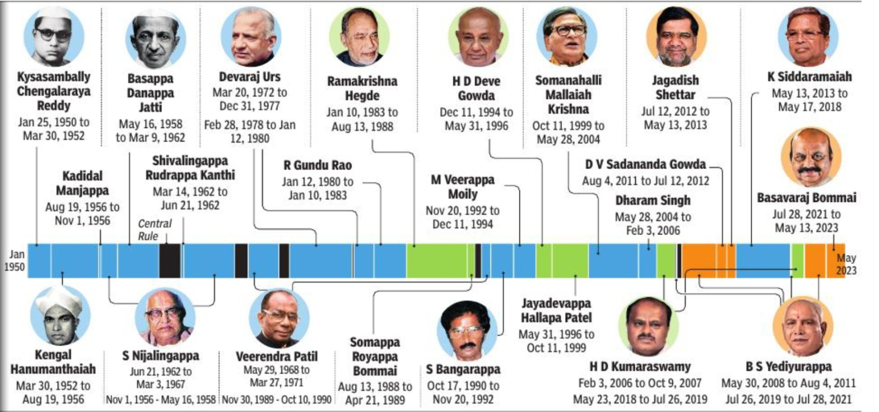

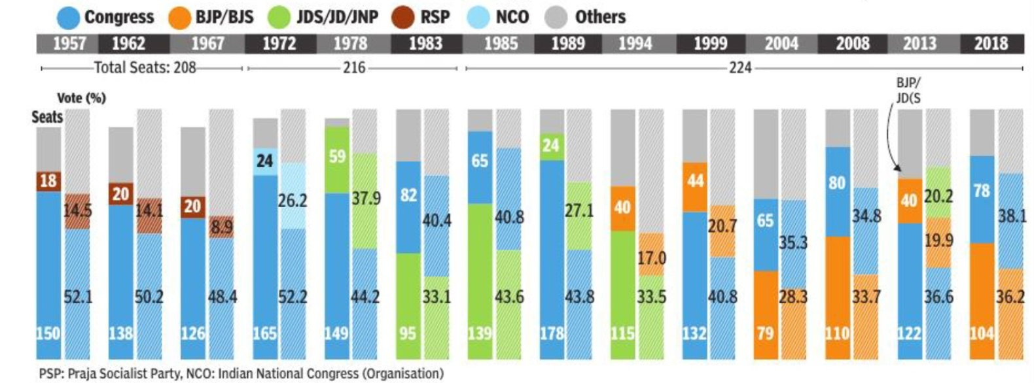

- Outgoing CM Bommai has already conceded defeat and said that his party will do a detailed analysis of results.
- Out of the 28 states and two Union territories with the legislature, the BJP is now in power only in 15
- The Congress had not won a single state election since the 2019 Lok Sabha elections, barring Himachal Pradesh
- The Congress has received 43% of the votes polled in the Karnataka elections.
- In terms of both vote share and number of seats, the Congress is set to have won the biggest victory in Karnataka since 1989, when it had won 178 seats and nearly 44% of the vote share.
- Karnataka witnessed a record voter turnout of 73.19% in the single-phase polling held on May 10.
- In the 2018 elections, BJP had won 104, Congress had won 80, JD(S) had won 37, and 'Others' had won three seats

- The Haryana government - approved liquor excise policy for 2023-24 that will permit large corporate offices in the state to serve beer, wine, and low-content alcoholic beverages within their premises
- Under the new policy, corporate offices with a minimum of 5,000 employees and a covered area of at least one lakh-square feet in a single self-owned or leased premises will be eligible to consume and possess alcohol
- According to the policy which will come into force from June 12, corporate offices seeking a license must have a canteen or eatery area of at least two thousand square feet.
- The L-10F license, which is required to serve or for consumption of low-content alcohol beverages, will be granted upon payment of an annual fixed fee of Rs 10 lakh.
- The new policy includes avant-garde (posh liquor vends in malls/shopping complexes) outlets, wooden or granite flooring, liquor vends in Industrial Model Townships and ban on open-air taverns.
- As per the new policy, the authorised drinking places for on premises consumption of liquor will be known as ‘Taverns’

- Andhra Pradesh Chief Minister YS Jagan Mohan Reddy - unveiled “Jaganannaku Chebudam”, a grievance redressal programme, recently on May 9

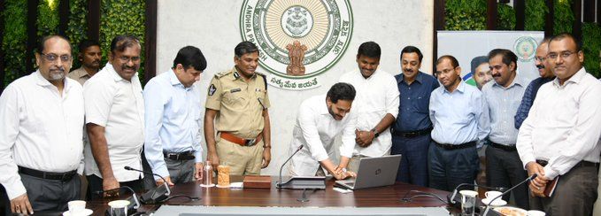

- Jagannanku Chebudam (Let us tell Jagan Anna) was launched by the chief minister at his camp office in Tadepalli near Vijayawada.
- He also launched a toll-free number — 1902 — for people to get in touch with the government for the redressal of their grievances
- The citizens may also visit their nearest village or ward secretariat and register grievances between 3 pm and 5 pm.
- The complaints and the progress in attending to them would be monitored by the chief minister’s office.
- The officials of all the departments have been instructed to keep track of the citizens grievances, solve them and conduct a weekly audit of pending and resolved grievances.
NATIONAL
- The Geological Survey of India - has found India's second Lithium reserves in Degana in Rajasthan's Nagaur district.
- The reserve has been found in Revant Hill where the tungsten mineral was discovered by the British in 1914 and was supplied all over the country to make weapons and later surgical goods.
- This reserve is at the pre-mining stage and only after more exploration the quantity of Lithium available in the reserve can be confirmed.
- Lithium, known as White Gold, is primarily used in the production of rechargeable batteries, particularly those used in electric vehicles, portable electronic devices, and power tools.
- Lithium-ion batteries have a high energy density, making them a popular choice for use in devices where weight and size are important factors.
- Lithium is said to be the softest and lightest metal in the world making it usable for manufacturing chargeable electronic and battery-powered goods
- On February 9, the first Lithium discovery was made in the Reasi district of Jammu and Kashmir where it is reported to have a stash of 5.9 million tonnes valued at $410 billion
- If the present area in Rajasthan is confirmed for mining, then the two existing reserves can meet 80% of India's Lithium demand
- Currently, India is import-dependent for several minerals like lithium, nickel and cobalt.
- India also has to buy 53.76% of its total Lithium imports from China
- The world's largest Lithium reserves of 21 million tonnes are currently in the country of Bolivia.
- Apart from Bolivia, there are also large reserves in Argentina, Chile and America.
- Despite this, China, which has reserves of 5.1 million tonnes of Lithium, continues to have a monopoly in the global market.

- India - is set to get its first pod taxi between Noida International Airport in Jewar and the Film City in Uttar Pradesh
- The Yamuna Authority has approved India’s first Personalised Rapid Transit project’s revised bid document.
- Following the approval from the Uttar Pradesh government, the construction will also be launched soon.
- The proposed route will be 12-14 km long and will have 12 stations.
- Pod Taxis are electric vehicles and driverless modes of transport.
- These are small automated cars which are designed to transport a handful of passengers from one place to another at a much faster speed.
- These vehicles move on a track and are electrically powered.
- These tracks are made separately on roads to avoid the regular day-to-day traffic.
- The estimated cost of the project is Rs 810 crore and is likely to be completed by the end of 2024.
- The pod taxi international transit system already exists in Dubai, Singapore, and Heathrow Airport in London among other places.

- India Post - signed an MoU with Confederation of All India Traders (CAIT) and Tripta Technologies for the launch of a new e-commerce portal called ‘Bharat EMart’

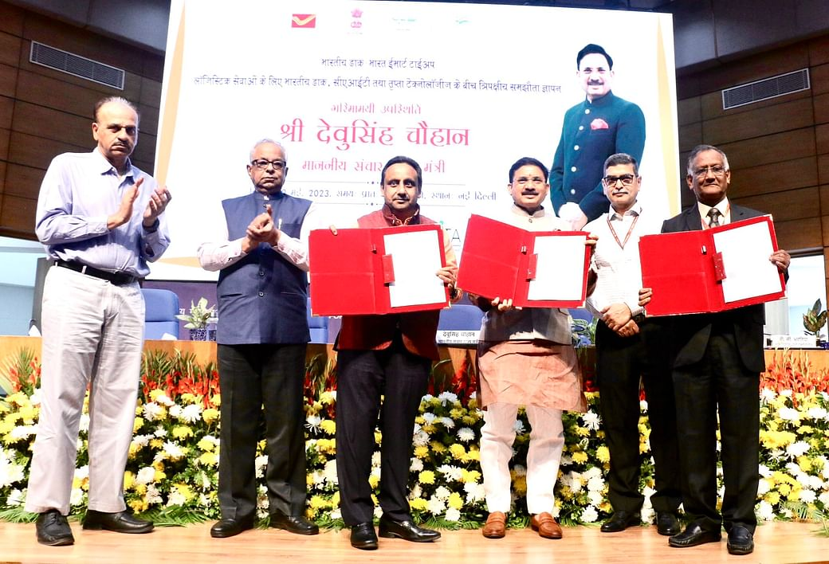

- The MoU was signed in Delhi in the presence of Minister of State for Communications, Devusinh Chauhan on May 9
- The new portal provides the facility of pick-up of consignments from the premises of traders and will ensure delivery at the doorsteps of the consignees across the country.
- Around eight crore traders associated with the CAIT will benefit from the new initiative
- India Post in the recent past has entered into similar agreements with Government e-Marketplace (GeM), Regional Centers of Tribal Cooperative Marketing Development Federation of India Limited (TRIFED), to provide pick-up and delivery of parcels at the doorsteps of the consignees.

- The government - has launched the SAKSHAM (Stimulating Advanced Knowledge for Sustainable Health Management), a Learning Management Information System (LMIS) of the Ministry of Health & Family Welfare.
- SAKSHAM is a dedicated and unified platform for providing online training and medical education to all health professionals in the country.
- It has been developed by the National Institute of Health & Family Welfare (NIHFW), New Delhi.
- The platform will assist capacity building of health professionals from primary health centres located in rural and remote areas in addition to tertiary care and corporate hospitals in metropolitan cities.
- Currently SAKSHAM: LMIS is hosting more than 200 public health and 100 clinical courses through online mode
INDIA AND NEIGHBOURS
- Union Minister Sarbananda Sonowal and Myanmar's Deputy Prime Minister Admiral Tin Aung San - jointly inaugurated the Sittwe Port in Rakhine State, Myanmar recently on May 9

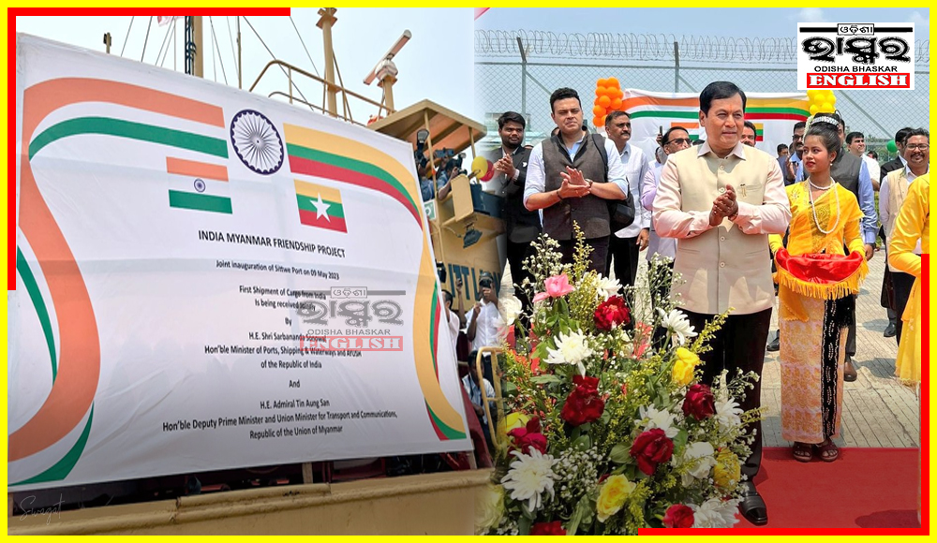

- During this event they received the first Indian Cargo ship which was flagged off from Syama Prasad Mookerjee Port, Kolkata.
- The Sittwe Port has been developed as part of the $484 million Kaladan Multi-Modal Transit Transport Project (KMTTP) funded by the government of India.
- With the development of Sittwe Port, the cost and time of transportation of goods between Kolkata and Agartala and Aizawl will decrease by 50%
- The port will provide an alternative connectivity between Mizoram and Haldia in West Bengal or any Indian port through the Kaladan river in Myanmar.
- Once the port becomes fully operational, it will link the East coast of India with the northeastern states
- It will also provide an alternative route for the region, to access international sea routes via the port.
- The seaport with a maximum capacity of 20,000 DWT is aimed at making Sittwe the maritime hub of Myanmar
SCIENCE, TECHNOLOGY & ENVIRONMENT
- The Indian Space Research Organisation (ISRO) - has recently announced a new introductory-level online training programme called Space Science and Technology Awareness Training (START).

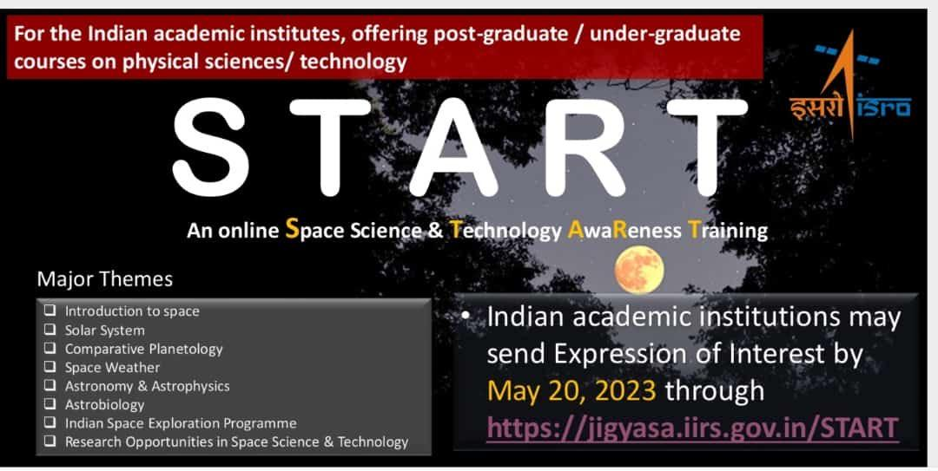

- START is aimed at postgraduate and final-year undergraduate students of Physical Sciences and Technology.
- The programme will cover various domains of Space Science, including Astronomy and Astrophysics, Heliophysics and Sun-Earth interaction, Instrumentation, and Aeronomy.
- It will be delivered by scientists from Indian academia and ISRO centres.
- The lectures will also cover topics on the Indian Space Science exploration programme and research opportunities in Space Science and technologies.
- The academic institutions can submit applications for the programme through the Jigyasa portal by May 20.

- NASA's Jet Propulsion Laboratory (JPL) - has developed a snake-like robot that it intends to deploy to Enceladus, one of Saturn's moons, in search of life.
- The self-propelled robot will be known as EELS (Exobiology Extant Life Surveyor)
- It can travel over a range of surfaces on Earth, the Moon, and "far beyond" in search for evidence of water and life-supporting environments
- The robot is approximately 5 meters long and weighs roughly 100 kilograms.
- It carries a unique device at the front to capture the environment in 3D and is equipped to send videos to Earth.

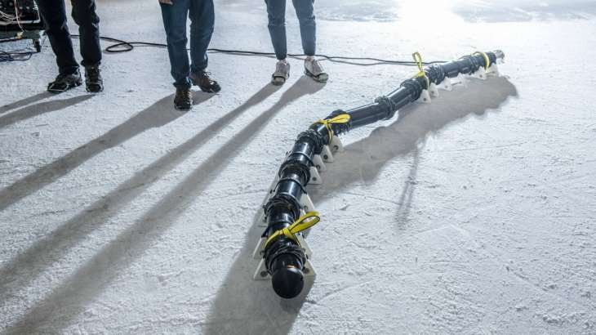

- The rest of the body can help with measurements such as pressure, electrical conductivity, and temperature of the soils and subsoils that have been accessed.
- The robot should be functional by the end of 2024 and will likely have to wait until a mission carrying it is launched

- NASA - launched two small satellites designed to track tropical cyclones in real-time from a base in New Zealand recently on May 8

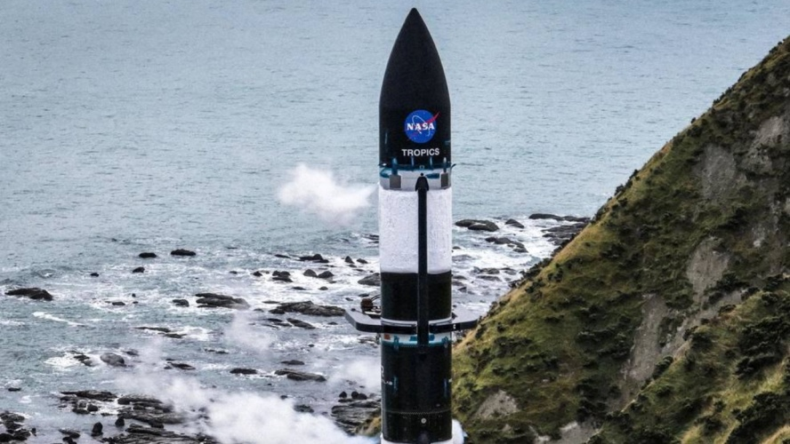

- The two satellites, known as CubeSats, were launched into low Earth orbit as part of the TROPICS (Time-Resolved Observations of Precipitation structure and storm Intensity with a Constellation of Smallsats) mission.
- The mission aims to improve weather predictions on devastating storms.
- The new storm trackers were sent into orbit on a rocket built by US company Rocket Lab
- They can fly over hurricanes every hour, compared to every six hours with current satellites.
- The TROPICS mission will provide researchers with information on rainfall, temperature, and humidity, allowing them to see storms evolve on an hourly basis.
- The second set of two more CubeSats will be launched in about two weeks also using Electron rockets from Rocket Lab
- When it is complete, TROPICS will form a constellation of four identical CubeSats designed to observe tropical cyclones, making observations more frequently than current weather tracking satellites.
SPORTS
- On May 13, Indian shooter Rhythm Sangwan - broke a 29-year-old world record in Women's 25m Pistol qualifications round at the ongoing ISSF World Cup in Baku, Azerbaijan.

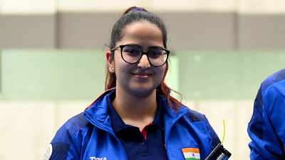

- The 19-year-old Sangwan shot a combined score of 595 to surpass the previous world record of 594 held jointly by Bulgaria's Diana Iorgova, China's Tao Luna, and Germany's Doreen Veenekamp.
- Diana Iorgova had first set the Women's 25m Pistol world record way back in May 1994 at a World Cup in Milan
- Iorgova's record was then matched by the Chinese shooter in 2002 before Veenekamp too levelled it at the 2023 ISSF World Cup held at Bhopal in March earlier this year.
- Rhythm in fact broke two world records on the day as she also claimed the junior women's 25m pistol qualification record.
- The previous record of 593 was set by Russia’s Nino Salukvadze shot at the European Championship in Zagreb in 1989, and was later levelled by Manu Bhaker in 2018 at the Asian Games in Jakarta.
- Rhythm was first to be eliminated in the eight-woman final with 10 hits in the first four five-shot series.
- Overall, she finished eighth in the women’s 25m pistol finals
- Earlier on May 10, Rhythm Sangwan had opened India's medal tally at the ISSF World Cup by winning a bronze medal in the Women's 10m Air Pistol event.
- India registered a no-medal day for the first time in the tournament on May 13.
- With this, India stayed second on the medals table with one gold, two silver and a bronze, while China was on top with three gold, a silver and two bronze.

